

# KOLEJ PROFESIONAL MARA BERANANG DIPLOMA IN COMPUTER SCIENCE

|  |  |  |
| --- | --- | --- |
| **COURSE NAME** | : | SOFTWARE APPLICATION TESTING |
| **COURSE CODE** | : | CSC 1273 |
| **ACADEMIC SESSION** | : | 3 2023/2024 |
| **TYPE OF ASSESSMENT** | : | ASSIGNMENT 1 |
| **DURATION** | : | 30/01/2024 – 13/02/2024 (2 WEEKS) |

**CLO2: Prepare test plan documentation based on developed system.**

**INSTRUCTION TO CANDIDATES:**

1. Late submissions after given due date will not be accepted.
2. Report should be written in using:
   1. Font type: Arial
   2. Size: 11 pts
   3. Line Spacing: 1.5

|  |  |
| --- | --- |
| **Personal Details** | |
| **Name** | MUHAMMAD EQMAL BIN NOOR RANIZ |
| **I/D Number** | BCS2211-026 |
| **Class** | DCS 4B |
| **Lecturer** | PUAN SHAHELLIN BINTI MANSUR HUANG |

|  |  |
| --- | --- |
| **Section / Question No.** | **Marks** |
|  |  |
|  |  |
|  |  |
|  |  |
|  |  |
| **Total** | **/ 30** |

# Scenario:

# Online social media refers to digital platforms and websites that facilitate the creation, sharing, and exchange of user-generated content, as well as the cultivation of virtual communities. These platforms serve as dynamic spaces where individuals connect, communicate, and interact with each other in real-time, transcending geographical boundaries. Users can share various forms of content, including text, images, videos, and links, allowing them to express their thoughts, opinions, and experiences. Social media has become an integral part of contemporary communication, providing a platform for personal expression, social networking, and information dissemination on a global scale.

# As the Software Quality Assurance (SQA) Executive in MySoft Sdn. Bhd. you are required to prepare a master test plan and conduct System Integration Testing (SIT) for ONE selected online social media platform.

# Below are the details of the tasks:

# Task 1

# Prepare a master test plan for online social media platform that includes:

# Test objective and scope

# Test schedule

# Test strategy

# Team members responsible for each testing

# List of features (features to be tested and features not to be tested)

# Task 2

# Define five (5) functional testing and three (3) non-functional testing of the selected social media platform.

# Conduct the System Integration Testing (SIT) test cases by referring to the given template as in Appendix that includes:

# Module Name

# Test Case ID

# Test Case Name

# Test Case Category

# Test Case Description

# Test Case Steps

# Expected Result

# Actual Result

# Status

# Test Data

# Attach appropriate screen shot for each test case conducted.

# Task 3

# Produce a test analysis and summary of the findings during the SIT processes.

# Provide recommendations or suggestions for any necessary improvements.

**TABLE OF CONTENT**

* 1. **MASTER TEST PLAN**
  2. Objectives and Scopes
  3. Testing Schedule
  4. Testing Strategies
  5. Team Members and Responsibilities
  6. List of Features to be Tested and not to be Tested

1. **SYSTEM INTERGATION TESTING**

2.1 SIT Test Cases

2.2 SIT Test Summary and Recommendations

* 1. **MASTER TEST PLAN**
  2. ***Objectives and Scopes***

**OBJECTIVE**

This project's goal is to set up the framework or structure of the social media platform that Twitter Inc. created and will be tested. This action was taken solely to guarantee that Twitter remains operational, secure, and user-friendly. The test master plan will be a written guide that explains social media's how and why to the final user.

**SCOPES**

The project's objectives are to test three non-functionalities and five functionalities of Twitter, a social media platform created by Twitter Inc, in order to ensure that there are no bugs in the app and to resolve any that are found until the test is completed successfully.

**1.2 Testing Schedule**

|  |  |  |  |  |
| --- | --- | --- | --- | --- |
| TESTING | START DATE | END DATE | DURATION | RESPONSIBLE PERSON |
| FUNCTIONAL TESTING | | | | |
| Login Function | 1/2/2024 | 2/2/2024 | 1 Days | Muhammad Eqmal |
| Account Registration Function | 3/2/2024 | 4/2/2024 | 1 Days | Abu Ubaidah |
| Forgotten Password Function | 5/2/2024 | 6/2/2024 | 1 Days | Muhammad Eqmal |
| Repost Function | 7/2/2024 | 8/2/2024 | 1 Days | Muhammad Eqmal |
| Edit Profile Function | 9/2/2024 | 10/2/2024 | 1 Days | Abu Ubaidah |
| NON-FUNCTIONAL TESTING | | | | |
| Browser Testing | 10/2/2024 | 10/2/2024 | 1 Days | Abu Ubaidah |
| Mobile App Testing | 11/2/2024 | 11/2/2024 | 1 Days | Muhammad Eqmal |
| Security Testing | 12/2/2024 | 12/2/2024 | 1 Days | Abu Ubaidah |

**1.3 Testing Strategies**

Ensuring The Robustness And Seamless Functionality Of The Twitter Platform Will Be Largely Dependent On Manual Testing. Testers Will Carry Out Practical Investigations Of The Functionality And User Interface, Run Test Cases, And Verify System Integration.

The Twitter Platform's Test Strategy For System Integration Testing (SIT) Is Crucial For Assessing The Platform's Functionality Across A Range Of Features And Interactions. SIT Covers A Range Of Test Levels, Each Concentrating On Essential Features Essential To Twitter's User Experience, Such As Website Usability, Profile Management, Content Repost, And Account Interactions.

A Wide Variety Of Testing Techniques Will Be Used To Guarantee Platform Dependability And User Happiness. These Include Repost Testing, Which Evaluates How User-Friendly It Is To Repost An Interesting Video To The User, Security Testing, Which Finds And Fixes Potential Vulnerabilities, And Compatibility Testing, Which Verifies Cross-Browser And Cross-Device Compatibility. Functional Testing Verifies Specific Features.

Following The Software Testing Life Cycle (STLC) Methodology, Testing Will Begin Using A Test Environment That Is Similar To The Production Setup After Development Is Complete. By Ensuring Testing Under Actual Circumstances, This Method Offers Precise Insights Into The Platform's Performance.

Resolving Significant Flaws And Obtaining Thorough Test Coverage And Documentation Are Testing Exit Criteria. To Guarantee Adherence To Standards And Procedures, The Software Quality Assurance (SQA) Team Will Thoroughly Document And Review All Testing Activities.

To Summarize, The Purpose Of This Testing Strategy For SIT Of Twitter's Platform Is To Maintain Functionality, Security, And Dependability While Emphasizing A Smooth User Experience. Adapting To Changing Needs And Technological Advancements Will Require Regular Reviews And Updates.

**1.4 Team Member Responsibility**

|  |  |
| --- | --- |
| Members | Responsibility |
| Muhammad Eqmal | * Verifying The Complete and Error-Free Functioning of The Module. For Instance, A Functional Mistake. * Drafting A Test Closure Report When the Experiment Is Over. |
| Abu Ubaidah | * Certifying That Each Module Has Undergone Testing and Passed Without A Hitch. * Setting Up the Testing Environment Before The Test Is Conducted. |

**1.5 List of Features**

***Function To Be Tested***

Functionality:

* Login Function
* Account Registration Function
* Forgotten Password Function
* Repost Function
* Edit Profile Function

Non-Functionality:

* Browser Testing
* Mobile App Testing
* Security Testing

***Not To Be Tested***

* Search Function
* Comment Post Function
* Post Analytics Function

**2.0 SYSTEM INTERGATION TESTING**

**2.1 SIT Test Cases**

|  |  |  |  |  |  |  |  |  |  |
| --- | --- | --- | --- | --- | --- | --- | --- | --- | --- |
| **Module** | **Test Case ID** | **Test Case Name** | **Test Category** | **Test Description** | **Steps** | **Expected Result** | **Actual Result** | **Status** | **Test Data** |
| **Login** | 1 | **T001**  Test Login Account | Functionality | 1) Verify User Is Able To Login Twitter Account At Website Url: <https://twitter.com/?lang=en>  2) Verify User Is Able To Click On Sign In Icon.  3) In Log In Page, Verify User Is Able To Enter Registered Email And registered Password.  4) Verify User Is Able to Click on Sign in Button  5) Verify User Is Able to Go to The Home Page After Successfully Login | 1) User Open Twitter Website Url: <https://twitter.com/?lang=en>  2) User Then Click On Login Button.  3) User Will Enter Their Registered Name  4) User Will Enter the Registered Password.  6) User Will Click on Sign In Button  7) The System Will Display Home Page | 1) Validate User Is Able to Login To Twitter Website Url:  <https://twitter.com/?lang=en>  (step 1)  2) Validate User Is Able to Click on Sign in Button.  (step 2)  3) In Sign in Page Validate User Is Able To Enter Registered Email And Correct Password.  (step 3 to 4)  4) Validate User Is Able to Click Sign in Button.  (step 5)  5) Validate User Is Able to Go To The Homepage After Successfully Login.  (step 6) | User Is Able to Sign in Without Any Error Message as Shown Below.  A screenshot of a computer  Description automatically generated  System Displayed Home Page After User Successfully Login as Shown Below  A screenshot of a video chat  Description automatically generated | Pass | Registered Email:  [eqmalnoorraniz@gmail.com](mailto:eqmalnoorraniz@gmail.com)  Registered Password:  Itik123 |
| **Registration** | 2 | **T002**  Test Registration Account | Functionality | 1) Verify User Is Able To Register Account At Twitter Website Url: <https://twitter.com/?lang=en>  2) Verify User Is Able To Click On Registration Icon.  3) In Registration Page, Verify User Is Able To Enter Email, Name And Birth Date.  4) Verify User Is Able To Click On Sign Up Button  5) Verify User Is Able to Go to The Home Page After Successfully Register Account | 1) User Open Twitter Website Url: <https://twitter.com/?lang=en>  2) User Then Click On Registration Button.  3) User Will Enter The Desired Name  4) User Will Enter The Desired Email.  5) User Will Enter their Birth Date  6) User Will Click On Sign Up Button  7) The System Will Display Home Page | 1) Validate user is able to lRegister Account twitter at website url:  <https://twitter.com/?lang=en>  (step 1)  2) Validate User Is Able To Click On Sign Up Button.  (step 2)  3) In Sign Up Page Validate User Is Able To Enter Desired Email, Name And Birth Date.  (step 3 to step 5)  4) Validate User Is Able to Click Sign Up Button.  (step 6)  5) Validate User Is Able to Go To The Homepage After Successfully Sign Up.  (step 7) | User Is Able To Register Account Without Any Error Message As Shown Below. **| Pass | Registered Email: [eqmalnoorraniz@gmail.com](mailto:eqmalnoorraniz@gmail.com)  Registered Name:  Kimal  Registered Birth Date:  Jul 2,2004 |
| **Forgotten Password Function** | 3 | **T003**  Test Forgotten Password Function | Functionality | 1) Verify User Is Able To Click On Forgot Password Icon.  2) In Forgot Password Page, Verify User Is Able to Enter Registered Email.  3) Verify User Is Able To Choose Reset Option Between Email Or Send To Mobile Phone On Sign Up Button  4) Verify User Is Able to Go to The Reset Password Page After Choose the Reset Option  5) Verify User Is Able to Enter Their New Password Other Than The Old Password.  6) Verify User Is Able To Click On Reset Password Button.  7)Verify User Is Able To Go To The Homepage After Successfully Reset The Password. | 1) User Then Click On Forget Password Button.  2) In Forgot Password Page, User Will Enter The Registered Email  3) User Will Click On The Next Button  4) User Will Choose Either Want To Send The Reset Password Link At Their Email Or At Their Number Phone.  5) User Will Open The Reset Password Link And Enter Their New Password.  6) User Will Go To The Twitter Login Page Enter And Log In With Their New Password.  7)The System Will Display The Homepage. | 1) Validate User Is Able To Click Forgot Password Button.  (step 1)  2) In Forgot Password Page Validate User Is Able To Enter Their Registered Email.  (step 2)  3) Validate User Is Able to Click On Desired Reset Link Between Email Or Their Number Phone.  (step 3)  4) Validate User Is Able To Open The Reset Password Link And Enter Their New Password.  (step 4 to step 5)  5) Validate User Is Able To login To Their Account With The New Password  (step 6)  6) Validate User Is Able To Go To The Homepage After Log In With Their New Password  (step 7) | User Is Able To Open The  Reset Password Page And Enter Their Email  A screenshot of a login screen  Description automatically generated  User Is Able to Choose The Reset Password Link And successfully Reset Their Password  A screenshot of a computer  Description automatically generated  System Displayed Home Page After User Successfully Login as Shown Below.  A screenshot of a video game  Description automatically generated | Pass | Registered Email:  [eqmalnoorraniz@gmail.com](mailto:eqmalnoorraniz@gmail.com)  Reset Password Link Option:  Email  Password Reset:  New Password is  Ayam123 Password Before  Itik 123 |
| **Repost Function** | 4 | **T004**  Test Repost Function | Functionality | 1) Verify User Is Able To See Videos And Picture At Homepage.  2) Verify User Is Able To Click Repost Button On The Video Or Picture That They Want To Repost.  3) Verify User Is Able To Click On Profile Button.  4) In Profile Page, Verify User Is Able to See Their Reposted Video Or Picture.  5) Verify User Is Able To Click On The Home Button To Go To The Homepage After They See Their Liked Picture Or Videos That They Liked. | 1) User Goes To The Homepage Of The Twitter  2) User Will Scroll On The Homepage And Find The Videos Or Pictures That They Want.  3) User Will Click On The Repost Button On The Picture Or Videos That They Want.  4) User Then Will Click On The Profile To Go To The Profile Page.  5) On The Profile Page User Will Be Able To See Their Liked Picture Or Videos That They Reposted.  6) User Then Will Click On The Home Button  7)The System Will Display The Homepage. | 1) Validate User Is Able To See Videos And Picture On The Homepage.  (step 1)  2) Validate User Is Able To Click On The Repost Button On The Video Or Picture  (step 2)  3) Validate User Is Able to Click On Profile Button  (step 3)  5) In Profile Page, Validate User Is Able To See Their Reposted Video Or Picture.  (step 4)  6) Validate User Is Able To Click On The Home Button  (step 5)  7) Validate User Is Able To Go To The Homepage After  Click On The Home Button.  (step 6) | User Is Able to See, Like and Repost Video And Image That They Want  A screenshot of a computer  Description automatically generated  User Is Able To Click On Profile And Able To Go To The Profile Page.    User Is Not Able to See The Video Or Image That They Like Recently At Their Profile  A screenshot of a computer  Description automatically generated | Failed | Liked Video Or Image Account:  PunchCat@Punchingcat  Reposted Video:  Car Crash Cat  Account That Reposted:  @eggmalz |
| **Edit Profile Function** | 5 | **T005**  Test Edit Profile Function | Functionality | 1) Verify User Is Able To Click On Profile Button.  2) In Profile Page, Verify User Is Able to Click On Edit Profile Button.  3) In Edit Profile Page, Verify User Is Able to Edit Profile And Click On Save Button.  4) Verify User Is Able To Click On Save Button After Successfully Edit Profile.  5) Verify User Is Able To Go To The Profile Page After Click On Save Button At Edit Profile. | 1) User Click On Profile Button At The Homepage Of The Twitter  2) User Will Go To The Profile Page And Click On Edit Profile Button.  3) User Will Go To The Edit Profile Page And will Edit Their Profile Following Their Preference.  4) After User Satisfied With Their Edit User Will Click On Save Button At The Edit Profile Page.  6) The System Will Display The Edited Profile Page Of The User. | 1) Validate User Is Able To Click On Profile Button.  (step 1)  2) Validate User Is Able To Go To The Profile Page.  (step 2)  3) In Profile Page Validate User Is Able to Click On Edit Profile Button.  (step 3)  4) In Edit Profile Page, Validate User Is Able To Edit Their Profile.  (step 4)  5) In Edit Profile Page Validate User Is Able To Click On Save Button.  (step 5)  6) Validate User Is Able To Go To The Profile Page After Successfully Save Their Edit.  (step 6) | User Is Able To Click On Profile Button And Go To The Profile Page    User Is Able Click On Edit Profile Button And Go To The Edit Profile Page    User Is Able To Save Their Edit And Go To The Profile Page | Pa  ss | Account That Been Used:  Kimalrnz  Email:  eqmalnoorraniz@gmail.com  Password:  Itik123 |
| **Browser Testing** | 6 | **T006**  Test Browser | Non- Functionality | 1) Verify User Is Able To Search And Open Twitter Website At Website Url: <https://twitter.com/?lang=en>  2) Verify User Is Able To Login Twitter Account At Twitter Website  3) Verify User Is Able To Go To The Homepage Of The Twitter After Successfully Log In.  4) Verify User Is Able To See The Content And Service That Twitter Provided.  5) Verify User Is Able To Log Out Account After Finished User The Twitter Website. | 1) User Will Open Any Browser Services And Search For Twitter At Their Website.  2) User Will Click On Twitter At their Website Search At Website Url:  <https://twitter.com/?lang=en>.  3) User Will Enter Their Account Information At Twitter Log In Page.  4) User Will Use the Twitter Service At Browser.  5) After The User Have Done Their Task. User Will  Click On Log Out Button.  6) User Will Go To The Twitter Log In Page At The Browser. | 1) Validate User Is Able To Search Twitter And Open Twitter Website Url:  <https://twitter.com/?lang=en>.  (Step 1 And Step 2)  2) Validate User Is Able To Log In Their Account And Use The Twitter Website Services.  (Step 3 And Step 4)  3) Validate User Is Able To Log Out And Go To The Log In Page At The Website.  (Step 5) | User Is Able To Search And Open Twitter At The Browser.    User Is Able To Use Twitter Services Easily At The Website.  A screenshot of a computer  Description automatically generated  User Is Able To Log Out The Twitter And Go To The Log In Page Back. | Pass | Browser That Been Use:  Chrome  Account That Been Used:  Kimalrnz  Email:  eqmalnoorraniz@gmail.com  Password:  Itik123 |
| **Mobile App**  **Testing** | 7 | **T007**  Mobile App Test | Non- Functionality | 1) Verify User Is Able To Search And Download Twitter At The App Downloader.  2) Verify User Is Able To Login Twitter Account At Twitter App.  3) Verify User Is Able To Go To The Homepage Of The Twitter After Successfully Log In.  4) Verify User Is Able To See The Content And Service That Twitter Provided At The Mobile App.  5) Verify User Is Able To Log Out Account After Finished User The Twitter Mobile App. | 1) User Click On App Downloader And Search For Twitter And Download It.  2) User Will Click On App And Open The App.  3) User Will Enter Their Account Detail At The Log In Page At The Mobile App.  4) User will Go To The Homepage After Successfully Log In Into The Twitter Mobile App.  6) After The User Use The Twitter Services User Will Log Out Their Account At The Log Out Service. | 1) Validate User Is Able To Search Twitter And Download Twitter App At The App Downloader.  (Step 1 And Step 2)  2) Validate User Is Able To Log In Their Account At the Log In Page And Use The Twitter Mobile Services.  (Step 3 And Step 4)  3) Validate User Is Able To Log Out And Go To The Log In Page At The Twitter Mobile App.  (Step 5) | User Is Able To Search And Twitter Mobile App At The App Downloader.    User Is Able To Use Twitter Services Easily At The Mobile App.    User Is Able To Log Out The Twitter And Go To The Log In Page Back At The Mobile App. | Pass | App That Downloaded The Twitter App:  App Store  Account That Been Used:  Kimalrnz  Email:  [eqmalnoorraniz@gmail.com](mailto:eqmalnoorraniz@gmail.com)  Password:  Itik123 |
| **Security Testing** | 8 | **T008**  Security Test | Non-Functionality | 1) Verify User Is Able To Login In Into The Twitter With The Correct Password Only.  2) Verify User Is Not Able To Log In With False Information Or Detail | 1) User Will Enter Their Registered Detail At The Log In Page  2) The System Will Display Homepage After Successfully Log In With The Correct Detail.  3) User The Will Log Out The Account | 1) Validate User Is Able To Log In With Registered Detail Only.  2) Validate User Be Able To Use Twitter Services.  3) Validate Is Not Able To Log In If One Of The Detail Is Wrong. | User Is Able To Log In Twiitter With The Correct Detail Only.    User Is Able To Use Twitter And Go To The Homepage.    User Is Able To See Incorrect Password Or Email If The Incorrect Detail Is Submitted. | Ab | Account That Been Used:  Kimalrnz  Email:  [eqmalnoorraniz@gmail.com](mailto:eqmalnoorraniz@gmail.com)  Password:  Itik123 |

**2.2 SIT Test Summary and Recommendations**

**SIT Test Summary:**

Name Of Testers:

Functionality Tester: Muhammad Eqmal

Non-Functionality Tester: Abu Ubaidah

Number of Test Cases Performed:

1. Login Functionality Testing:

* Test Case ID: T001
* Status: Pass
* Description: The login functionality has been thoroughly tested, and all steps executed as expected. Users were able to log in without encountering errors, and the home page was displayed correctly after successful login.

2. Registration Functionality Testing:

* Test Case ID: T002
* Status: Pass
* Description: Registration process was successful without any errors. Users were able to register an account and navigate to the home page afterward.

3. Forgotten Password Functionality Testing:

* Test Case ID: T003
* Status: Pass
* Description: Users were able to successfully reset their password using the forgotten password feature. The system displayed the homepage after password reset.

4. Repost Functionality Testing:

* Test Case ID: T004
* Status: Failed
* Description: There was a failure encountered in this functionality. Users were unable to see the recently reposted videos or images on their profile page. Further investigation is needed to address this issue.

5. Edit Profile Functionality Testing:

* Test Case ID: T005
* Status: Pass
* Description: Users were able to edit their profile successfully and save the changes. The system displayed the edited profile page after saving the changes.

6. Browser Testing:

* Test Case ID: T006
* Status: Pass
* Description: Browser testing was successful. Users were able to search, log in, use Twitter services, and log out without any issues.

7. Mobile App Testing:

* Test Case ID: T007
* Status: Pass
* Description: Mobile app testing was successful. Users were able to search, download, log in, use Twitter services, and log out without any issues.

8. Security Testing:

* Test Case ID: T008
* Status: Pass
* Description: Security testing was successful. The system allowed log in only with correct credentials, and users were unable to log in with false information.

Conclusion:

Muhammad Eqmal and Abu Ubaidah tested the system's functionality for a number of features.

The functionalities related to login, registration, forgetting passwords, editing profiles, and testing of the browser and mobile app were all completed successfully.

Nevertheless, a failure occurred during the functionality testing of the repost (Test Case ID: T004). On their profile page, users couldn't see recently reposted photos or videos.

The system was successfully tested for security (Test Case ID: T008), confirming that false information could not be logged in and that only legitimate logins were accepted.

In summary, the majority of the system's functionalities worked as planned, but there is a problem with the repost functionality that needs to be looked into further and fixed.

**Recommendations:**

Repost Functionality Improvement:

* Issue: Users are unable to see recently reposted content on their profile page.
* Suggestion: Conduct thorough debugging and testing to identify the root cause of this issue. Ensure that reposted content is correctly displayed on users' profile pages.
* Evidence: Review user feedback and conduct additional testing with different scenarios to replicate the problem and pinpoint the exact cause of the issue.

Enhanced Error Handling and Messaging:

* Issue: Lack of clear guidance or error messages in case of issues encountered during login, registration, or other processes.
* Suggestion: Implement robust error handling mechanisms and provide clear, user-friendly error messages to guide users in troubleshooting and resolving issues effectively.
* Evidence: Analyze user complaints or support tickets related to login or registration difficulties. Conduct usability testing to evaluate the clarity and effectiveness of error messages.

Expand Test Coverage:

* Issue: Test coverage may be limited, potentially overlooking edge cases or unanticipated scenarios.
* Suggestion: Expand test coverage to include additional functionalities and edge cases, ensuring comprehensive testing of the Twitter platform.
* Evidence: Conduct a thorough review of the existing test cases and identify areas where test coverage can be expanded. Consider incorporating user feedback and analyzing past issues to identify potential areas for improvement.

Continuous Security Testing:

* Issue: While security testing was successful in the current iteration, ongoing security testing is crucial to maintaining robust security measures.
* Suggestion: Implement a continuous security testing process, including regular vulnerability assessments, penetration testing, and code reviews to proactively identify and address security vulnerabilities.
* Evidence: Stay updated with the latest security threats and vulnerabilities in web applications. Regularly review security best practices and consider engaging external security experts for comprehensive security assessments.

By implementing these recommendations, the Twitter platform can improve its functionality, user experience, and security posture, ensuring a seamless and secure user experience for its millions of users worldwide.

**Screenshot:**

T001 Login

T002 Registration

T003 Forgot Password

T004 Repost Function

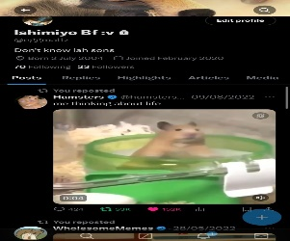

T005 Edit Profile

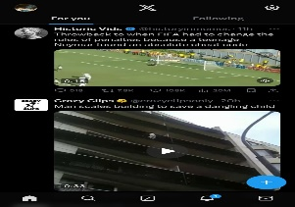

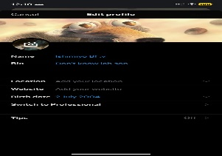

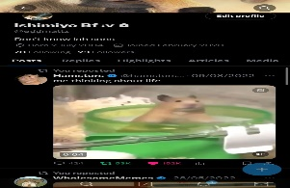

T006 Browser Testing

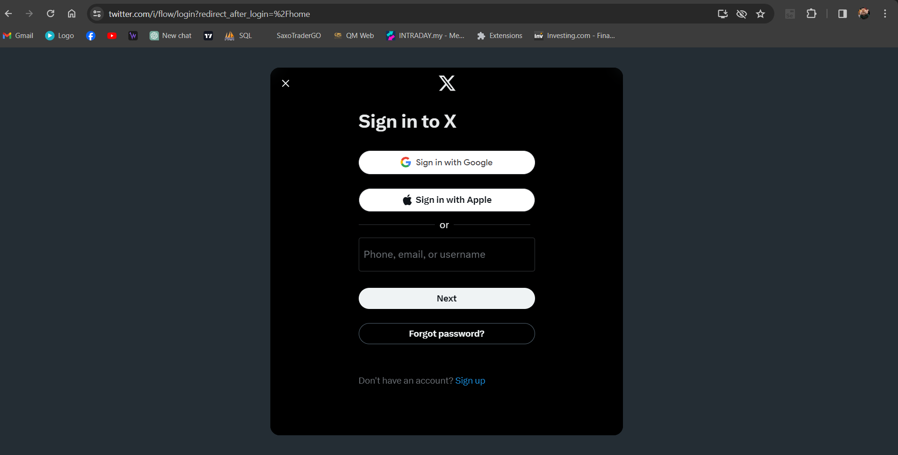



T007 Mobile App

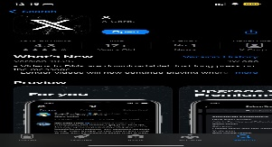



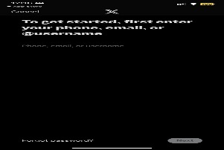

T008 Security Testing

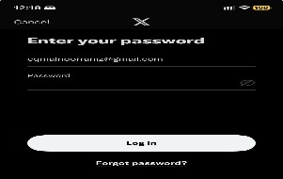



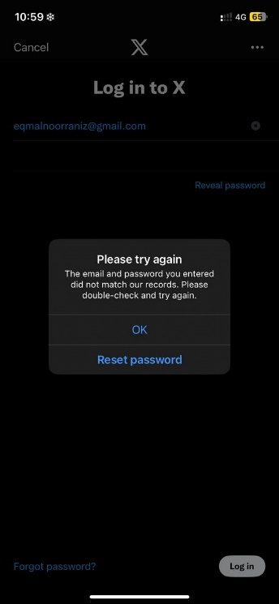

# Assessment Rubrics:

| **Criteria/Task** | | **Attainment Scale** | | | | **Marks Weight** | **Student Attainments** |
| --- | --- | --- | --- | --- | --- | --- | --- |
| **1**  **Very Weak** | **2**  **Weak** | **3**  **Fair** | **4**  **Good** | **Scale Marks** |
| Prepare a master test plan for online social media platform | i. Test Objectives and Scopes | - Provide brief description of the objectives.  **OR**  - Provide brief description of the scope. | - Provide brief description of the objectives and scope. | - Provide detail description of the objectives and scope. | **-** Provide detail description of the objectives and scope with clear defined and well documented. | **0.5** |  |
| ii. Test Schedule | - Provide a brief test schedule with lack of detail or flexibility. | - Provide a brief test schedule with lack of detail or flexibility. | - Provide a test schedule with details including milestone **OR** date line. | - Provide a well-structured test schedule with details including milestone and date line. | **0.5** |  |
| iii. Test Strategy | - Provide a brief outline test strategy in general explanation. | - Provide a brief outline test strategy but lacks some detail in test levels, types, or methodologies. | - Provide an explanation test strategy including test levels, types, methodologies, and entry/exit criteria | - Provide a comprehensive and well- documented test strategy including test levels, types, methodologies, and entry/exit criteria. | **0.5** |  |
| iv. Team members responsibility | - Provide at least **one (1)** testers’ name **without** responsibility description. | - Provide at least **one (1)** testers’ name **with** clear responsibility description. | - Provide at least **two (2)** testers’ names **without** responsibility description. | - Provide at least **two (2)** testers’ names **with** responsibility description. | **0.5** |  |
|  | v. List of features (features **to be tested** and features **not to be tested**) | - Provide a list of features **to be tested**.  **OR**  - Provide list of features **NOT** to be tested. | - Provide a list of features **to be tested**.  **AND**  - Provide list of features **NOT** to be tested. | - Provide a list of features **to be tested**.  **AND**  - Provide list of features **NOT** to be tested.  - Lists provided are not clearly defined. | - Provide a list of features **to be tested**.  **AND**  - Provide list of features **NOT** to be tested.  - Lists provided are clearly defined. | **0.5** |  |
| Define the functional testing and non-functional testing of the selected social media platform. | Functional Testing and Non-. Functional Testing | - Define **one (1)** correct functional testing.  **AND**  - Define **one (1)** correct non-functional testing. | - Define **two (2)** correct functional testing.  **AND**  - Define **one (1)** correct non-functional testing. | - Define **three (3)** correct functional testing.  **AND**  - Define **two (2)** correct non-functional testing. | - Define **four (4)** and **MORE** correct functional testing.  **AND**  - Define **three (3)** correct non-functional testing. | **1** |  |
| Conduct the System Integration Testing (SIT) test cases by referring to the given template as in Appendix that includes elements as below: Module NameTest Case IDTest Case NameTest Case CategoryTest Case DescriptionTest Case StepsExpected ResultActual ResultStatusTest Data | Functional Testing and Non-. Functional Testing | - Include **ALL** the required elements with incomplete data for functional testing and non-functional testing. | - Include **ALL** the required elements with complete data for functional testing and non-functional testing. | - Include **ALL** the required elements with complete data for functional testing and non-functional testing.  - provide comprehensive Test Case description  **OR**  - provide comprehensive Test Case Steps | - Include **ALL** the required elements with complete data for functional testing and non-functional testing.  - provide comprehensive Test Case description  **AND**  - provide comprehensive Test Case Steps | **2** |  |
| Attach appropriate screen shots for each test case conducted. | Functional Testing and Non-. Functional Testing | - Provide inappropriate screen shots for **SOME** functional test cases.  **AND**  - Provide inappropriate screen shots for **SOME** non -functional test cases. | - Provide appropriate screen shots for **ALL** functional test cases.  **OR**  - Provide appropriate screen shots for **ALL** non -functional test cases. | - Provide appropriate screen shots for **ALL** functional test cases.  **OR**  - Provide appropriate screen shots for **ALL** non -functional test cases. | - Provide appropriate screen shots for **ALL** functional test cases.  **AND**  - Provide appropriate screen shots for **ALL** non -functional test cases  - All the screen shots are clear and readable presented in the report. | **1** |  |
| Produce a test analysis and summary of the findings during the SIT processes which include:   1. number of test cases performed. 2. number of test case(s) passed. 3. number of test case(s) failed. 4. passing rate. 5. severity levels. 6. name of tester(s). 7. number of defects found. 8. describe the defect(s). 9. conclusion. | Functional Testing and Non-. Functional Testing | - Produce incomplete test analysis and summary for the conducted SIT. | - Produce complete test analysis and summary with a brief explanation for the conducted SIT. | - Produce complete test analysis and summary with a comprehensive explanation for the conducted SIT. | - Produce complete test analysis and summary with a comprehensive explanation for the conducted SIT.  - Provide a clear conclusion regarding the conducted SIT. | **0.5** |  |
| Provide recommendations or suggestions for any necessary improvements. | Functional Testing and Non-. Functional Testing | - Provide brief and unclear recommendations or suggestions for improvements. | - Provide unclear recommendations or suggestions for improvements. | - Provide clear recommendations or suggestions for improvements. | - Provide clear recommendations or suggestions for improvements.  - State an appropriate evidence(s) to support the given suggestions. | **0.5** |  |
| **Total Marks Earned** | | | | | | | **/30** |
| **Total Percentage (15%)** | | | | | | |  |